Devsec-ops LAB
Dushyant Singh Raghav
500120590
Devops-B3
Lab Exercise 4
Signed Commits in Git and GitHub
Step 1 – Generate or Use an Existing GPG Key
- Check for existing keys
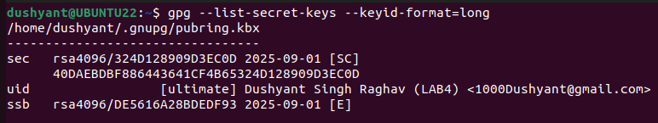
- If no key exists, generate a new one
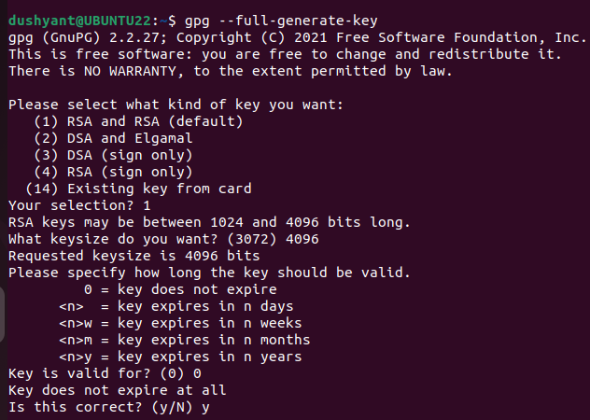
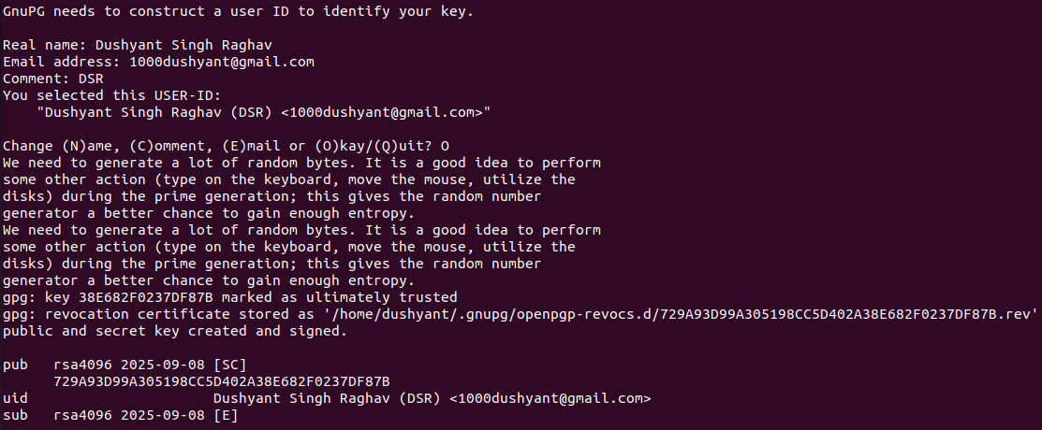
- Get your key ID
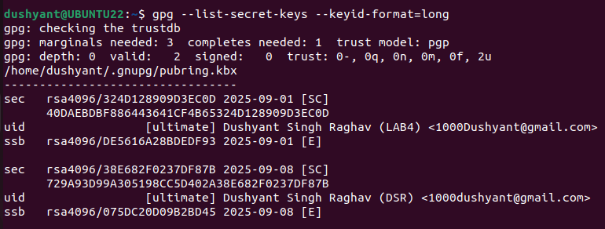

Step 2 – Add GPG Key to GitHub

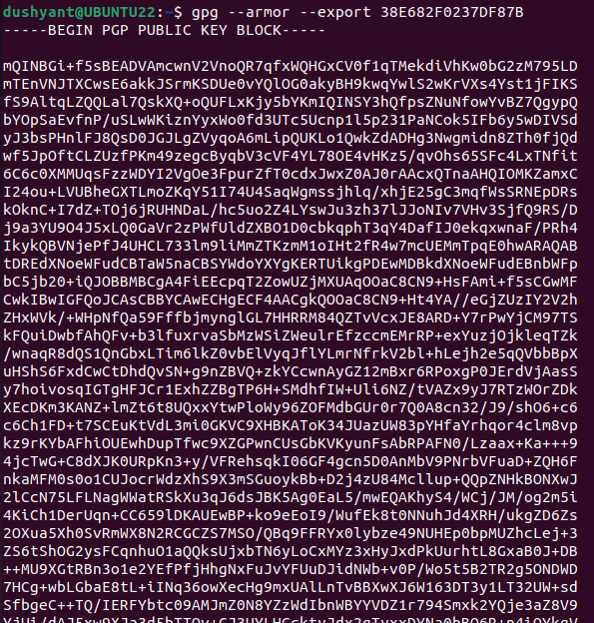

Step 3 – Configure Git for Signed Commits
- Tell Git which key to use:
Step 4 – Make a Signed Commit
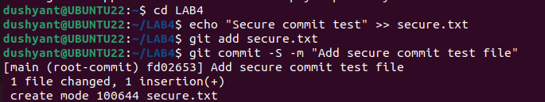
Step 5 – Push and Verify on GitHub
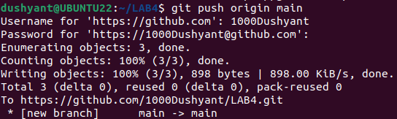
Step 6 – Local Verification of Commit